

**A**

**PROJECT REPORT ON**

**“Adventure Map Website System”**

**BACHELOR OF BUSINESS ADMINISTRATION (COMPUT ER APPLICATION) T.Y.BBA(C.A.) SEM V**

**2024-2025**

**SUBMITTED TO**

**Savitribai Phule Pune University DEVELOPED BY**

**Buddhivant Tejas Ganesh**

**Gatkul Somnath Dajiba**

**UNDER THE GUIDENCE OF**

**ASHA MANE**

**Annasaheb Magar College Hadapsar Pune-411028.**

**DEPARTMENT : BBA(CA)**



**Annasaheb Magar College Hadapsar Pune-411028.**

**DEPARTMENT of BBA(CA)**

## CERTIFICATE

This is certified that Buddhivant Tejas & Gatkul Somnath students Bachelor of Business Administration (Computer Application)

T.Y.BBA(C.A.) semester V has satisfactory completed the project work on “**Adventure Map Website System”** as per the syllabus laid down by the Savitribai Phule Pune University during the academic year 2024-2025

Date :-

Exam seat no Exam seat no

Project In charge Head of Department

Internal Examiner External Examiner

**ACKNOWLEDGEMENT**

First of all, while presenting this project I express my sincere gratitude to almighty god for his grace and blessing that helped me to complete this project work successfully.

We are also grateful to our teachers Prof. Asha mane mam for their encouragement, help and support from time to time I have been benefited by their valuable guidance, able support constructive suggestions and rich experience in the field of software development.

I would also like to express my deep sense of obligation and reverence to my parents for their constant support without whom this. Work not have been seen the light of the day.

I am also thanks to my teachers for their support and helping to our system project.

**Buddhivant Tejas Ganesh**

**Gatkul somnath Dajiba**

## INDEX

|  |  |  |
| --- | --- | --- |
| **SR NO.** | **PARTICULAR NAME** | **PAGE NO** |
| **1** | **INTRODUCTIONS :-** |  |
|  | * 1. **Profile of system**   2. **Scope of system**   3. **Purpose of the system** | 6  7  8 |
| **2** | **SYSTEM ANALYSIS :-**   * 1. **Feasibility Study**   2. **Fact Finding Technique**   3. **Hardware and Software Requirement** | 10  11-12  13 |
| **3** | **SYSTEM DESIGN :-**   * 1. **Entity Relationship Diagram**   2. **Use Case Diagram**   3. **Class Diagram**   4. **Component Diagram**   5. **Deployment Diagram**   6. **Object Diagram**   7. **File Design**   8. **Data Dictionary** | 15  16  17  18  19-20  21-24  25 |
| **4** | **FORMS AND REPORT**   * 1. **Input & output screens** | 26-28 |
| **5** | **TESTING** | 29 |
| **6** | **ADVANTAGES & LIMITATION** | 30-32 |
| **7** | **CONCLUSION** | 33 |
| **8** | **FUTURE ENHANCEMENT** | 34 |
| **9** | **REFERENCES** | 35 |

**1.INTRODUCTION**

* 1. **Profile of System**

**1. User Profiles**

* Track individual activities, earned points, and collected badges.
* Customizable profiles that display achievements, badges, and adventure progress.

**2. Challenges & Quests**

* Users complete location-based challenges, such as checking in or visiting specific places.
* Scavenger hunts and location discoveries as gamified quests.
* Completing challenges awards points and badges.

**3. Points & Badge System**

* Users earn points for completing challenges and quests.
* Badges are awarded for achieving milestones or specific objectives.
* Points contribute to the leaderboard ranking.

**4. Leaderboard**

* Ranks users based on their accumulated points.
* Competitive element to encourage participation and exploration.

**1.2 Scope of System**

* **Registration and Authentication**: Users can create accounts and securely log in.
* **Profile Management**: Ability to update personal information and track points and badges.
* **Interactive Map:** Displays nearby locations with detailed information and custom markers.
* **Points and Badges:** Users earn points for visiting locations and can view badge progress.
* **Leaderboards:** Compare points with friends and other users.
* **Exploration Challenges:** Participate in challenges for additional points and badges.
* **Reviews and Feedback**: Leave reviews and ratings for visited locations.

1.3 Purpose of System

The Adventure Map Web App is designed to encourage exploration and foster a sense of adventure by motivating users to discover and engage with nearby locations. Through gamification, the app incorporates a points and badges system, making participation in activities and challenges enjoyable and rewarding. It promotes community building by allowing users to share their experiences through reviews and feedback, creating a network of explorers who can learn from one another. Additionally, the app highlights local businesses and attractions, driving traffic to these locations. User engagement is enhanced through features like leaderboards and exploration challenges, fostering competition and social interaction among users. The system also collects valuable data on user preferences and behaviors, enabling improvements and personalized experiences. An administrative interface allows for effective management of users, locations, and content, ensuring the app remains safe, relevant, and user-friendly. Overall, the Adventure Map Web App aims to enrich users' experiences while providing essential tools for managing and promoting local attractions.

2 SYSTEM ANALYSIS

**2.1 FEASIBILITY STUDY**

Economical feasibility : -

Economical analysis is the most frequently used technique for evaluating the effectiveness of a proposed system. If benefits outweight costs, a decision is taken to design and implement the sysyem.

Technical Feasibility : -

This is concerned with specifying equipment and software that will successfully satisfy the user requirments. The technical needs of the system may very considerably, but might include

Facility to communicate data to distant locations. Response time under certain conditions.

Operational Feasibility:-

This is mainly related to human organizational andpotical aspects. The points to be considered are:

What changes will be brought with the system ? What organizational structure is disturbe.

**2.2 Fact Finding Technique**

* **Interviews**:
  + Conducting one-on-one or group interviews with stakeholders, such as users, administrators, and business owners, to gather detailed insights and requirements.
  + Pros: Direct feedback, ability to clarify doubts, and explore in-depth issues.
  + Cons: Time-consuming and may be biased based on the interviewee’s perspective.
* **Surveys and Questionnaires**:
  + Distributing structured surveys or questionnaires to a larger audience to collect quantitative data about user needs and preferences.
  + Pros: Can reach a wide audience quickly and provide statistical data.
  + Cons: Limited depth of information and potential misunderstanding of questions.
* **Observation**:
  + Observing users as they interact with existing systems or perform relevant tasks to understand workflows and pain points.
  + Pros: Provides real-world insights into user behavior and system usage.
  + Cons: May not capture the full context or reasons behind actions.

**2.3 HARDWARE & SOFTWARE REQUIREMENT**

HARDWARE :-

1. Intel Pentium 3 processor or higher
2. RAM 256 MB
3. 40 GB HDD (Hard Disk)
4. CD Drive 16X or higher

SOFTWARE :-

1. OPERATING SYSTEM : MICROSOFT WINDOWS.
2. FRONT END TOOL : COREJAVA .
3. BACK END : MYSOL .

**3 SYSTEM DESIGN**

* + 1. **Entity Relationship Diagram**

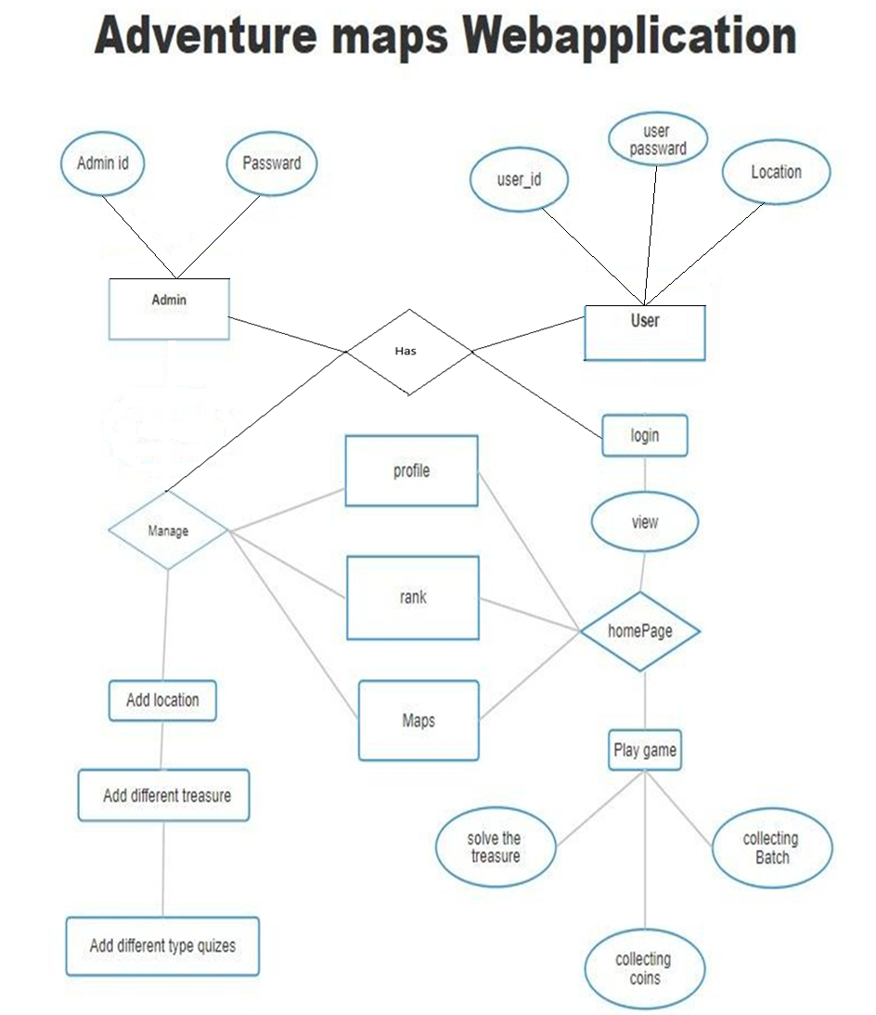

**3.2Use Case Diagram**

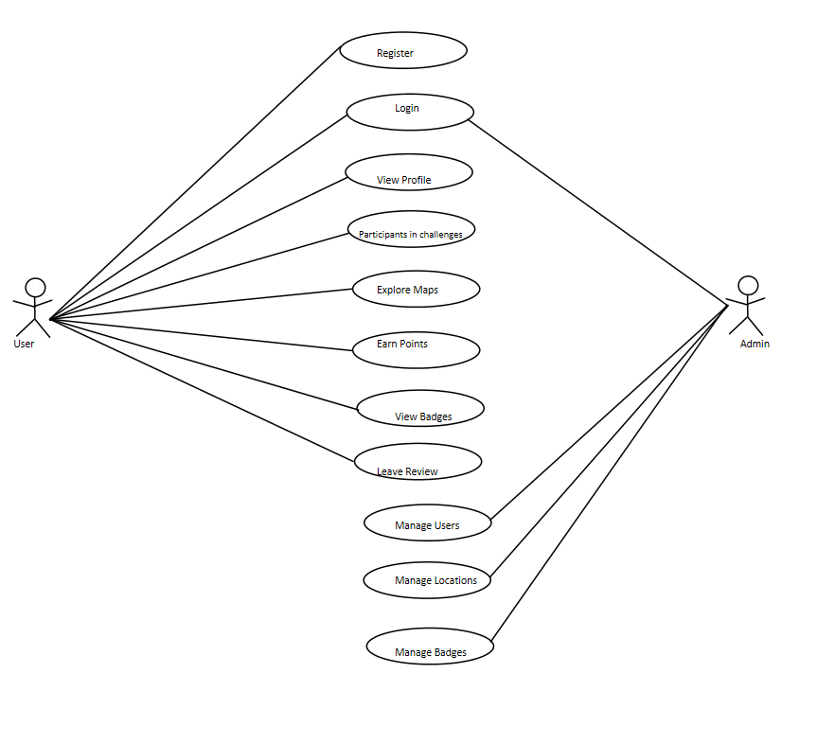

**3.3 Class Diagram**

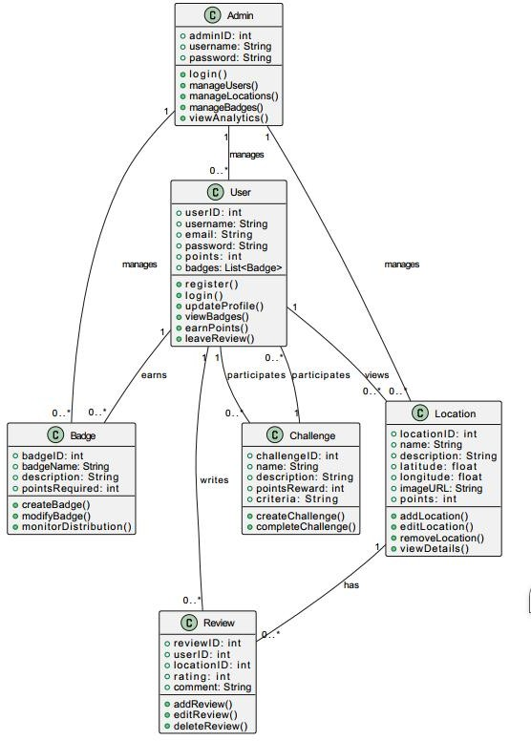

* 1. **Component Diagram**

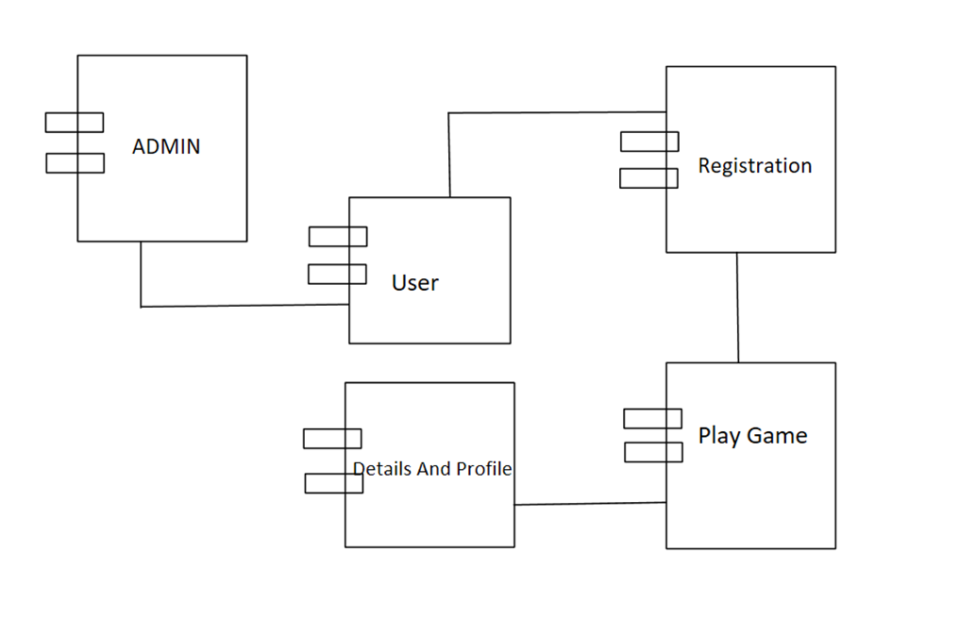

**3**.**5 Deployment Diagram**

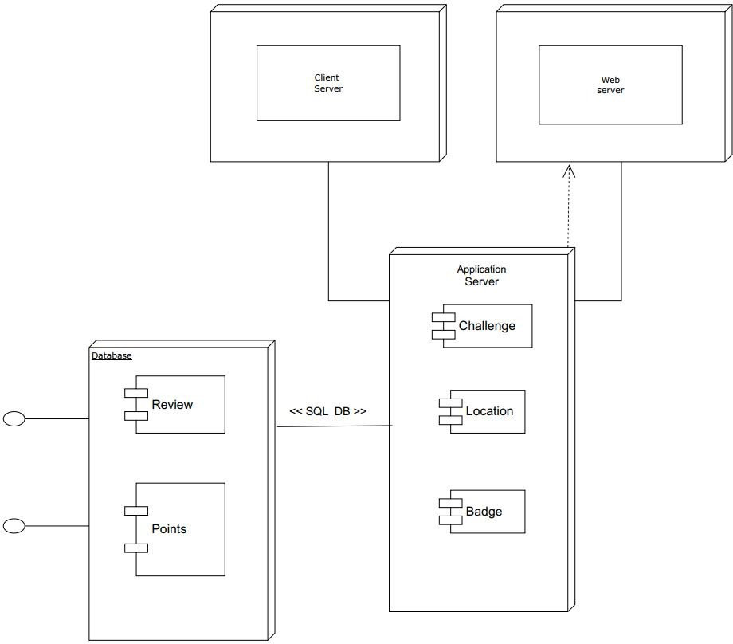

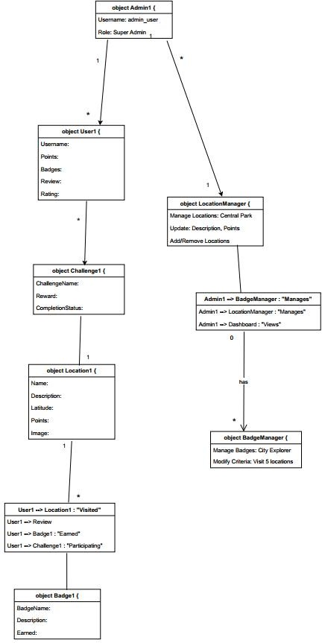**3.6 Object Diagram**

**3.7 File Design**

**1. Users Data File:**

|  |  |  |
| --- | --- | --- |
| **Field Name** | **Description** | **Data Type** |
| **user_id** | **Unique identifier for each** | **INT (Primary Key)** |
| **username** | **Username selected by the** | **VARCHAR(50)** |
| **email** | **Email address of the user** | **VARCHAR(100)** |
| **password** | **Hashed password for** | **VARCHAR(255)** |
| **profile_pic** | **URL to the user's profile** | **VARCHAR(255)** |
| **total_points** | **Total accumulated points** | **INT** |
| **created_at** | **Date and time of user** | **TIMESTAMP** |
| **last_login** | **Last login date and time of** | **TIMESTAMP** |

**2. Badges Data File:**

|  |  |  |
| --- | --- | --- |
| **Field Name** | **Description** | **Data Type** |
| **badge_id** | **Unique identifier for each badge** | **INT (Primary Key)** |
| **badge_name** | **Name of the badge** | **VARCHAR(50)** |
| **description** | **Description of the badge** | **TEXT** |
| **badge_image** | **URL to the badge image** | **VARCHAR(255)** |
| **badge_criteria** | **Criteria required to earn** | **VARCHAR(255)** |
| **points_reward** | **Points awarded** | **INT** |
| **Field Name** | **Description** | **Data Type** |

**3 Challenges Data File:**

|  |  |  |
| --- | --- | --- |
| **Field Name** | **Description** | **Data Type** |
| **challenge_id** | **Unique identifier for** | **INT (Primary Key)** |
| **challenge_name** | **Name of the challenge** | **VARCHAR(100)** |
| **description** | **Detailed description** | **TEXT** |
| **challenge_type** | **Type of challenge** | **VARCHAR(50)** |
| **start_date** | **Start date and time** | **TIMESTAMP** |
| **end_date** | **End date and time** | **TIMESTAMP** |
| **reward_badge_id** | **Badge awarded upon** | **INT (Foreign Key)** |
| **reward_points** | **Points awarded upon** | **INT** |

**4. Leaderboard Data File:**

|  |  |  |
| --- | --- | --- |
| **Field Name** | **Description** | **Data Type** |
| **leaderboard_id** | **Unique identifier** | **INT (Primary Key)** |
| **user_id** | **Reference to the user** | **INT (Foreign Key)** |
| **rank** | **User's rank on the** | **INT** |
| **total_points** | **User's total points** | **INT** |
| **updated_at** | **Date and time of the** | **TIMESTAMP** |
| **Field Name** | **Description** | **Data Type** |
| **leaderboard_id** | **Unique identifier** | **INT (Primary Key)** |

3.8 Data Dictionary

|  |  |  |  |  |
| --- | --- | --- | --- | --- |
| **Fields Name** | **Fields** | **Data type & Data Size** | **constraints** | **Table Name** |
| Adventures_db | id | int (30) | Index | User |
|  | Pass | varchar(255) | - |  |
|  | Name | Varchar(22) |  |  |
|  | Email | Varchar(25) |  |  |
| Adventures_db | Latitude | int(30) | Primary | Location |
|  | Longitude | varchar(50) | - |  |
|  | Name | varchar(100) | - |  |
|  | Imagepath | Varchar(23) | - |  |
| Adventures_db | User_point | int(11) | Primary | Rankup |
|  | User_number | Text | - |  |
|  | User_name | Text | - |  |
|  | Points | int(30) |  |  |
|  |  |  | - |  |

1. **FORMS AND REPORT**

**4.1 Input & output screens**

**Login form :**

**Sign up Form :**

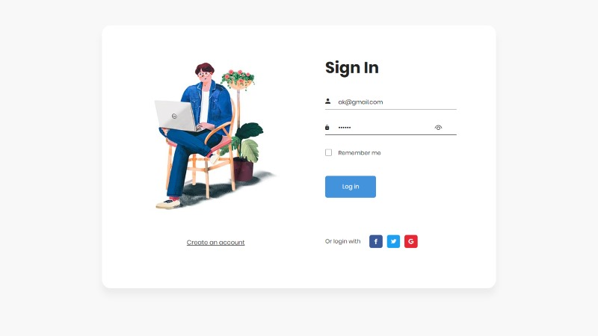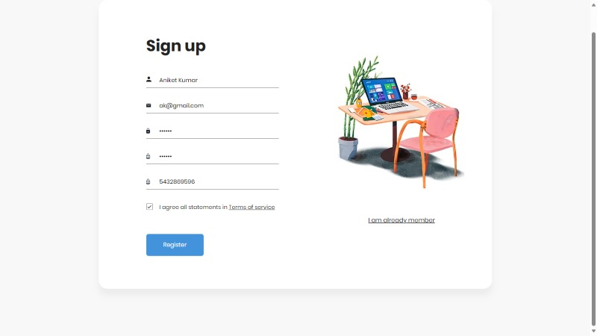

**4.2 Admin Forms**

**Admin Login :**

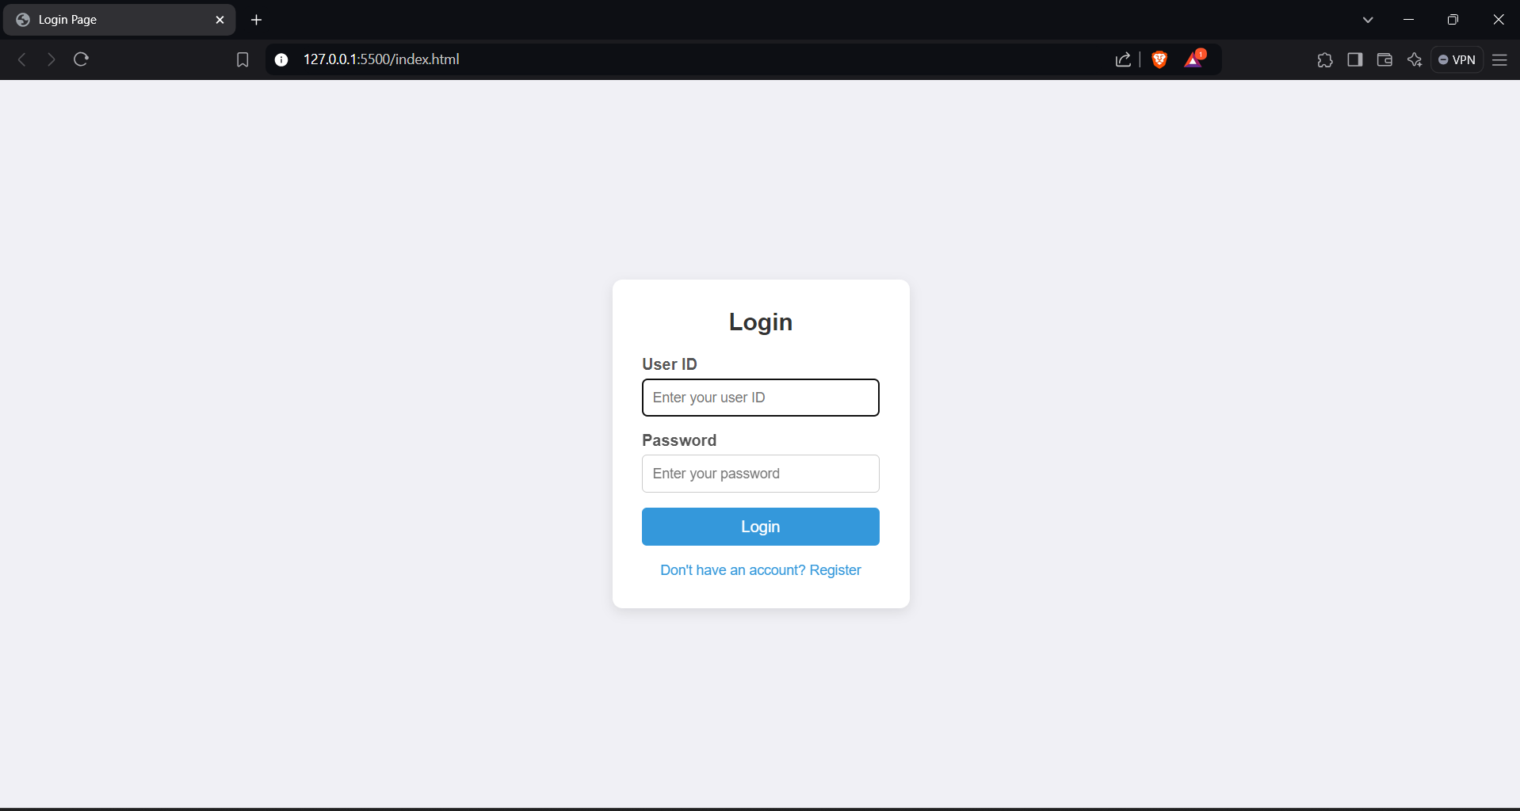

**Admin Dashboard :**

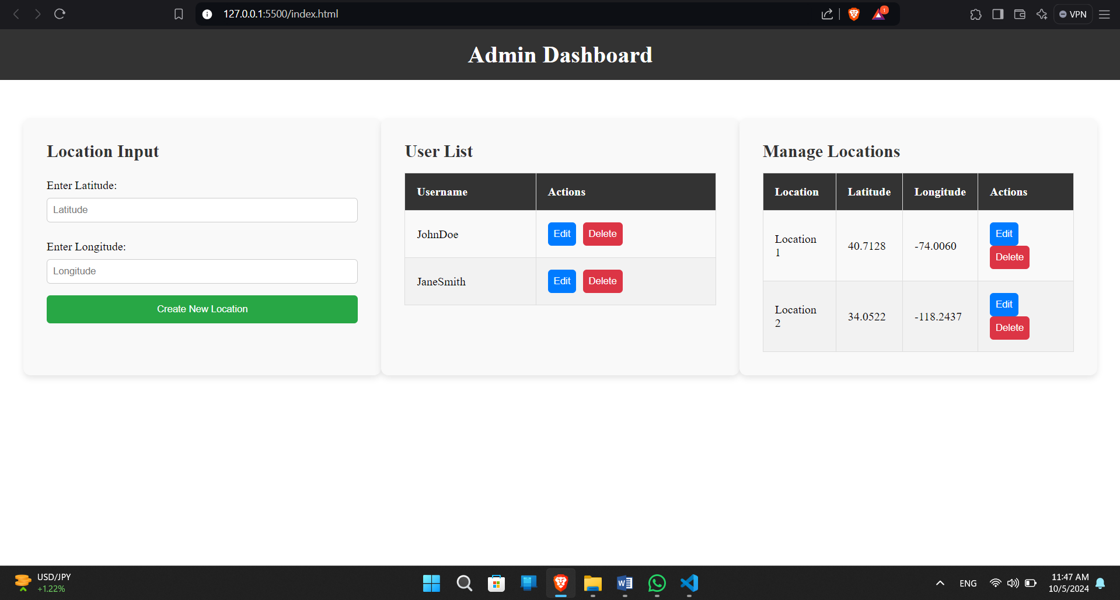

**5.Testing**

Testing the Adventure Map web application is crucial to ensure a seamless and engaging user experience, while also maintaining system performance and reliability. The testing process will cover multiple aspects, including functional, usability, performance, security, and compatibility testing.

**Black Box Testing :**

Black box testing focuses on testing the functionality of the application without knowledge of the internal code or structure. The tester interacts with the system by inputting data and analyzing the output, ensuring that the system behaves as expected.

**1. Functional Testing:**

* User Registration & Login: Input valid and invalid credentials to verify if the registration and login processes work correctly.
* Map Interaction: Test map functionality by zooming, searching locations, and verifying if markers appear on the map when users check-in at places.
* Badges & Points: Earn badges by completing challenges and check if the badges and points are awarded and reflected in the user’s profile.

**2. Usability Testing:**

* Test the ease of navigation within the app, such as moving between the map, profile, challenges, and leaderboards.
* Ensure that error messages are displayed for invalid actions, such as entering incorrect login information.

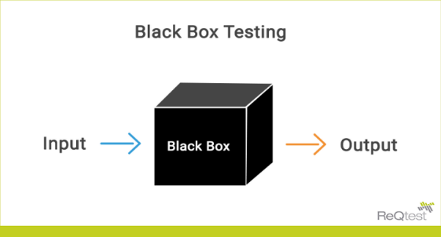

**5.2 White Box Testing**

**White Box Testing** evaluates the internal logic and code of the system. Testers have complete visibility of the codebase and design, ensuring the internal workings are functioning correctly.

* **Purpose**: To verify the internal workings of the system, such as code logic, algorithms, and data flow.
* **Tests Include**:
  1. **Code Flow and Logic**:
     + Verified whether the **route planning algorithm** computes the shortest and safest paths using efficient algorithms like Dijkstra's or A*.
     + Checked that **conditional logic** ensures only active and available buses are assigned to students.
  2. **Path Coverage**:
     + Ensured that all possible execution paths in the code are tested for correct route generation and student assignment.
     + Tested **error handling** routines in cases where GPS signals fail or if student data is incomplete.
  3. **Boundary Testing**:
     + Examined edge cases in the route optimization algorithm, such as locations on city outskirts or students far from typical routes.
     + Tested boundary conditions where the number of students exceeds bus capacity to see if the system reallocates students or issues alerts.
* **Advantages**: Provides insight into how well the code is written and identifies inefficiencies or logic errors.
* **Status**: Pass/Fail.

**6. Advantage and Disadvantages**

### **6.1 Advantages**

1. **Real-World Interaction:**
   * Encourages players to explore their surroundings and engage with their communities.
2. **Scalability:**
   * You can easily add new locations, quizzes, and badges, allowing the game to grow over time.
3. **Rich Data:**
   * Leverage existing geographic data to create informative and engaging quizzes about various locations..
4. **Social Features:**
   * Players can share their achievements and experiences, promoting community interaction and potentially attracting new players.

**6.2 Disadvantages**

1. **Location Dependency:**
   * The game relies on users being in specific physical locations, which may limit participation for those who cannot travel easily.
2. **Privacy Concerns:**
   * Tracking users’ locations can raise privacy issues; you’ll need to handle data securely and transparently.
3. **Technical Challenges:**

Implementing geolocation and integrating with the Google Maps API may require advanced technical skills and maintenance

.

**7 Conclusion**

**7.1 Conclusion of System**

Creating an adventure map game using the Google Maps API offers an engaging way to encourage exploration and interaction with real-world locations. The advantages include real-world interaction, customization, scalability, and enhanced user engagement through social features. However, challenges such as location dependency, privacy concerns, technical complexities, and competition must be carefully managed.

In conclusion, if effectively executed, this system can provide a unique and rewarding experience for players, blending physical activity with gamification, while also fostering community involvement. Careful planning and user-centric design are key to overcoming potential drawbacks and ensuring success.

**8 Future Enhancement**

**1.** **Augmented Reality (AR) Integration**

* **Feature:** Implement AR features that overlay digital elements onto the real world, enhancing the immersive experience.
* **Benefit:** Players can interact with virtual objects at real-world locations, making the game more engaging and visually appealing.

**2. AI-Driven Personalization**

* **Feature:** Use AI to analyse player behaviour and preferences to tailor quizzes, challenges, and routes.
* **Benefit:** Personalized experiences can increase user satisfaction and retention.

**3. Dynamic Content Updates**

* **Feature:** Enable real-time updates to quizzes and challenges based on current events, seasonal themes, or player feedback.
* **Benefit:** Keeping content fresh encourages players to return and engage regularly.

**4. Enhanced Social Features**

* **Feature:** Integrate more social elements, such as team challenges, multiplayer modes, and community events.
* **Benefit:** Fosters a sense of community and competition, making the game more interactive.

**5. Gamified Learning Experiences**

* **Feature:** Collaborate with educational institutions to create learning-focused challenges related to local history, ecology, or culture.

**9 References**

**Websites Reference: -**

* + 1. [WWW.GOOGLE.COM](http://WWW.GOOGLE.COM)
    2. [WWW.YOUTUBE.COM](http://WWW.YOUTUBE.COM)
    3. <https://www.geeksforgeeks.org/python-django/>
    4. <https://www.javatpoint.com>
    5. <https://www.w3schools.org/>

**Book Reference: -**

**1.Core java**

**(Third Year TY BBA (CA) Semester 5)**

**2.Object Oriented Software Engineering**

**(Third Year TY BBA (CA) Semester 5)**

Thank You